A Mini Project/Intern-ship Assessment report

**2 in 1(Snake+2048) Game**

**Using Javascript**

Submitted in partial fulfilment of award of

**BACHELOR OF TECHNOLOGY**

Degree in

Computer Science and Engineering (AIML)

BY

**NISHANT VERMA (2200821530034)**

Under the guidance of

**Mrs. Shiwani Agarwal**

**Mr. Rohit Singh**

(Assistant professors CSE department)



**DEPARTMENT OF COMUTER SCIENCE AND ENGINEERING**

**Moradabad Institute of Technology, Moradabad (U.P.)**

**Session: 2023-2024**

i

# CERTIFICATE

Certified that the Mini Project titled “**2 in 1(Snake+2048) using Javascript**” submitted by **Nishant Verma** **(2200821530034)** in their own work during his intern-ship at under the supervision of CTO of the company.

The certificate is verified by Mr. Rohit Kumar and Mrs. Shiwani Agarwal, Assistant professors at Moradabad Institute of Technology, Moradabad and is recommended that the candidate may now be evaluated for their Industrial Training work by the university.

**Date:**

Mrs. Shiwani Aggarwal Mr. Rohit Singh

(Assistant Professor) (Assistant Professor)

ii

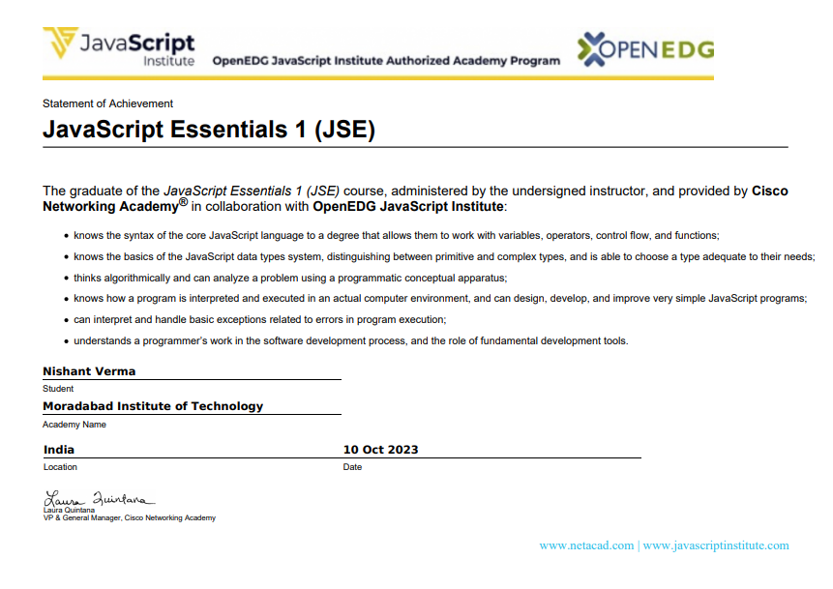CERTIFICATE

# iii

Abstract

**2-in-1 Game (Snake + 2048) using JavaScript**

The "2-in-1 Game (Snake + 2048)" project is a web-based gaming application that seamlessly combines two classic games, Snake and 2048, into a single, engaging user experience. Developed primarily using JavaScript, HTML, and CSS, the project offers a dynamic and interactive platform accessible across various web browsers.

**Features:**

1. **Snake Game:**
   * **Gameplay:** Players control a snake that moves around the game area, consuming food to grow longer.
   * **Challenges:** Avoiding collisions with the snake's own body and the game boundaries adds complexity.
   * **Scoring:** Points are awarded for each food item consumed, with the goal of achieving the highest score.
2. **2048 Game:**
   * **Gameplay:** Players merge identical numbered tiles by sliding them across the game grid in four directions.
   * **Objective:** The primary goal is to reach the 2048 tile through strategic tile merging.
   * **Scoring:** Points are calculated based on merged tiles, encouraging players to aim for higher-numbered tiles.

**Integration:**

The unique aspect of this project lies in the integration of both games within a single interface. Users can seamlessly switch between the Snake and 2048 games, providing a diverse gaming experience. The project includes an intuitive menu system for easy navigation between the two games.

**Technologies Used:**

* **JavaScript:** Core game logic and interactivity.
* **HTML:** Structure and layout of the web page.
* **CSS:** Styling and visual presentation.
* **Web Technologies:** Utilizes modern web standards for cross-browser compatibility.

**Conclusion:**

The "2-in-1 Game (Snake + 2048)" project offers a blend of strategy, agility, and entertainment, providing users with a nostalgic experience while introducing innovative gameplay. The project's use of JavaScript ensures smooth and responsive interactions, making it accessible to a wide audience. Overall, this gaming application serves as a testament to the versatility and creativity that can be achieved through web-based game development using JavaScript.

Top of Form

iv

ACKNOWLEDGEMENT

Apart from my efforts, the success of any project depends largely on the encouragement and guidelines of many others. I express deep sense of gratitude to God for giving me the strength for the strength for the successful completion of the project. I express my heartfelt gratitude to my parents for constant encouragement while carrying out this project.

I express my deep sense of gratitude to the luminary Director **Dr. Rohit Garg** who has been continuously motivating and extending their helping hand to us. I express my sincere thanks to HOD of CS department MIT, for constant encouragement and the guidance provided during this project.

At last, my sincere thanks to **Mrs. Shiwani Agarwal and** **Mr. Rohit Singh** who critically reviewed my project and helped in solving each and every problem that occurred during implementation of the project.

Nishant Verma-2200821530034

v

# TABLE OF CONTENTS

CONTENT PAGE NO.

* *Certificate ii-iii*
* *Acknowledgement iv*
* *Abstract v*
* *Table of Contents vi*
* *Chapter1 7-8*
* *Introduction 7*
* *Objective 7*
* *Project Background 8*
* *Project Overview 8*
* *Chapter2 9-10*
* *Development Phase*
* *Chapter3 11-12*
* *Features and Functionality*
* *Chapter 4 13-24*
* *Source code(snippet) 13-22*
* *Snapshot(output) 23-24*
* *Conclusion 25*
* *Executive Summary 26*
* *Reference 27*

*Top of Form*

Bottom of Form

**Chapter-1**

**Introduction-**

In the ever-evolving landscape of online gaming, the "2-in-1 Game (Snake + 2048)" stands as a testament to innovation and nostalgia. This web-based gaming application seamlessly merges two iconic games, Snake and 2048, offering users a captivating and diverse gaming experience. Developed with a focus on modern technologies such as JavaScript, HTML, and CSS, this project aims to deliver a harmonious blend of strategy and arcade-style action.

The allure of classic games lies in their ability to transcend generations, sparking memories and creating timeless enjoyment. With this in mind, our project takes the beloved Snake and 2048 games and intertwines them into a single, cohesive platform. Users will find themselves navigating the strategic challenges of 2048 and the adrenaline-pumping intensity of controlling a snake—all within the same interface.

Objective-

The primary objective of the "2-in-1 Game (Snake + 2048)" project is to create an engaging and innovative web-based gaming application that combines the timeless appeal of Snake and 2048. The project aims to achieve the following objectives:

1. **Integration of Classic Games:**
   * Seamlessly merge the gameplay mechanics of Snake and 2048 within a single, cohesive interface.
   * Enable users to switch between the Snake and 2048 games effortlessly, offering a diverse and entertaining gaming experience.
2. **User-Centric Design:**
   * Prioritize user experience by designing an intuitive menu system for easy navigation between the two games.
   * Ensure responsive and visually appealing graphics to cater to users of varying ages and gaming preferences.
3. **Technical Excellence:**
   * Implement robust game logic using JavaScript to ensure smooth and interactive gameplay.
   * Utilize HTML and CSS to create a well-structured and visually appealing web-based gaming application.
4. **Challenge and Entertainment:**
   * Provide users with strategic challenges in the 2048 game, encouraging critical thinking and puzzle-solving skills.
   * Deliver the fast-paced and reflex-driven action of controlling a snake in the classic Snake game, offering an adrenaline-pumping experience.
5. **Cross-Platform Accessibility:**
   * Develop a responsive design that allows the gaming application to be accessible across various devices and web browsers.
   * Ensure compatibility with modern web standards to reach a broad audience.

Project Background-

The genesis of the "2-in-1 Game (Snake + 2048)" project stems from a desire to reimagine and revitalize classic gaming experiences. In the realm of web-based games, the amalgamation of two iconic titles—Snake and 2048—promises to deliver a nostalgic yet innovative venture.

Classic games hold a special place in the hearts of gamers worldwide, invoking memories of simpler times and the joy derived from fundamental yet addictive gameplay. Recognizing the enduring appeal of Snake and 2048, this project seeks to bridge the generational gap by seamlessly blending the strategic puzzle-solving of 2048 with the fast-paced action of controlling a snake.

Project Overview-

The "2-in-1 Game (Snake + 2048)" project is a web-based gaming application that combines two iconic games, Snake and 2048, into a single, seamless experience. The project aims to provide users with a diverse and engaging gaming platform that merges the strategic challenges of 2048 with the fast-paced action of controlling a snake.

**Key Components:**

1. **Snake Game Integration:**
   * Users can experience the classic Snake game, where they control a snake to consume food and grow longer.
   * Challenges include avoiding collisions with the snake's own body and the game boundaries.
2. **2048 Game Integration:**
   * The 2048 game introduces strategic gameplay, where users slide tiles on a grid to merge identical numbered tiles.
   * The objective is to reach the 2048 tile through thoughtful tile merging.

**Project Objectives:**

* Integrate the gameplay mechanics of Snake and 2048 seamlessly.
* Provide an intuitive menu system for easy navigation between the two games.

**Conclusion:**

The "2-in-1 Game (Snake + 2048)" project seeks to offer a memorable and enjoyable gaming experience by combining the best elements of two classic games. With a focus on user experience, technical excellence, and the fusion of tradition with innovation, the project is poised to captivate a diverse audience in the ever-evolving landscape of web-based gaming.

Top of Form

Bottom of Form

**Chapter-2**

**Development Phase-**

The development phase of the "2-in-1 Game (Snake + 2048)" involves several steps, each focusing on specific aspects of the game creation process. Below is a detailed breakdown of the development phase:

**1. Project Setup:**

* **Create Project Structure:**
  + Set up the project directory with organized folders for HTML, CSS, JavaScript, and images.
* **Initialize Version Control (Optional):**
  + If working in a team or to track changes, consider initializing a version control system (e.g., Git).

**2. HTML Structure:**

* **Basic HTML Skeleton:**
  + Create the basic structure of the HTML file (index.html).

**3. CSS Styling:**

* **Style Game Components:**
  + Define styles for game elements, buttons, backgrounds, and any other visual aspects.

**4. Game Logic Implementation:**

* **Implement Snake Game Logic:**
  + Develop the logic for controlling the snake's movement, collision detection, and food consumption.
* **Implement 2048 Game Logic:**
  + Develop the logic for sliding tiles, merging identical tiles, and tracking the game state.
* **Integrate Both Games:**
  + Combine the logic for both games, allowing users to switch between them seamlessly.
  + Manage user input for each game mode.
* **User Experience Testing:**
  + Gather feedback on the user interface and overall gaming experience.
* **Bug Identification and Fixing:**
  + Identify and fix any bugs or issues that arise during testing.

**5. Cross-Browser Compatibility:**

* **Browser Testing:**
  + Test the game across different web browsers to ensure compatibility (e.g., Chrome, Firefox, Safari).
* **Responsive Design Check:**
  + Confirm that the game works well on various devices and screen sizes.

**6. Optimization:**

* **Code Optimization:**
  + Optimize JavaScript code for better performance.
  + Minimize and concatenate CSS and JavaScript files.
* **Asset Optimization:**
  + Optimize image assets for faster loading times.

**7. Deployment:**

* **Choose Hosting Platform:**
  + Decide where the game will be hosted (e.g., GitHub Pages, Netlify, or a custom server).
* **Upload Files:**
  + Upload HTML, CSS, JavaScript, and image files to the chosen hosting platform.
* **Domain Configuration (Optional):**
  + If using a custom domain, configure the necessary settings.

**8. Documentation:**

* **Code Documentation:**
  + Provide comments and documentation within the code for better understanding.
* **User Guide (Optional):**
  + Create a user guide or readme file explaining how to play the game.

**9. Refinement and Updates:**

* **Gather Feedback:**
  + Collect user feedback and analyze any issues or improvement suggestions.
* **Implement Updates:**
  + Make necessary refinements or additions based on user feedback.
* **Version Control Commit (Optional):**
  + If using version control, commit changes and document updates.

By following these detailed steps during the development phase, you can ensure a systematic and organized approach to creating the "2-in-1 Game (Snake + 2048)" while addressing various aspects of game design, logic, and user experience.

**Chapter-3**

**Features and Functionality-**

The "2-in-1 Game (Snake + 2048)" incorporates a blend of classic and strategic gaming experiences. Below are the features and functionalities that contribute to the overall gameplay:

**1. Dual Gaming Modes:**

* **Snake Game:**
  + Classic Snake gameplay where users control a snake to consume food and grow.
  + Avoid collisions with the snake's body and game boundaries for survival.
* **2048 Game:**
  + Puzzle-solving gameplay where users slide tiles to merge identical numbered tiles on a grid.
  + The goal is to reach the 2048 tile through strategic tile merging.

**2. Seamless Game Switching:**

* Users can effortlessly switch between Snake and 2048 modes.
* Intuitive menu system for a smooth transition between the two games.

**3. Responsive User Interface:**

* User-friendly design with responsive elements for various screen sizes and devices.
* Visually appealing graphics and layout for an engaging user experience.

**4. Game Controls:**

* **Snake Game Controls:**
  + Arrow keys or swipe gestures to control the snake's direction.
* **2048 Game Controls:**
  + Arrow keys or swipe gestures to slide tiles in four directions.

**5. Scoring System:**

* **Snake Game Scoring:**
  + Points awarded for each food item consumed, with additional points for longer snake lengths.
* **2048 Game Scoring:**
  + Points calculated based on merged tiles, encouraging users to aim for higher-numbered tiles.

**6. Challenges and Objectives:**

* **Snake Game Objectives:**
  + Achieve the highest possible score by consuming food and avoiding collisions.
* **2048 Game Objectives:**
  + Reach the 2048 tile by merging tiles strategically without running out of moves.

**7. User Feedback and Visual Cues:**

* Visual cues for successful actions (e.g., snake growing, tile merging).
* Sound effects or visual indicators for achieving milestones or completing objectives.

**8. Game Over and Reset:**

* Clear indication and feedback when the game is over.
* Option to reset or replay the game without reloading the page.

**9. Cross-Browser Compatibility:**

* Ensures the game works seamlessly across various web browsers (e.g., Chrome, Firefox, Safari).

**10. Technical Foundations:**

* JavaScript for core game logic and interactivity.
* HTML for structure and layout.
* CSS for styling and visual presentation.

**11. Innovation and Nostalgia:**

* Innovative combination of classic games.
* Aesthetic and gameplay elements that evoke nostalgia for retro gaming experiences.

**12. User Guide and Documentation:**

* Clear instructions on how to play each game mode.
* In-game or external documentation explaining controls and objectives.

**13. Continuous Improvement:**

* Gather user feedback for ongoing improvements and updates.
* Consider adding new features, game modes, or refinements based on user input.

By incorporating these features and functionalities, the "2-in-1 Game (Snake + 2048)" aims to provide users with an entertaining and dynamic gaming experience that seamlessly fuses the charm of classic games with modern innovation.

Top of Form

*Chapter-4*

***Source code(Snippet)-***

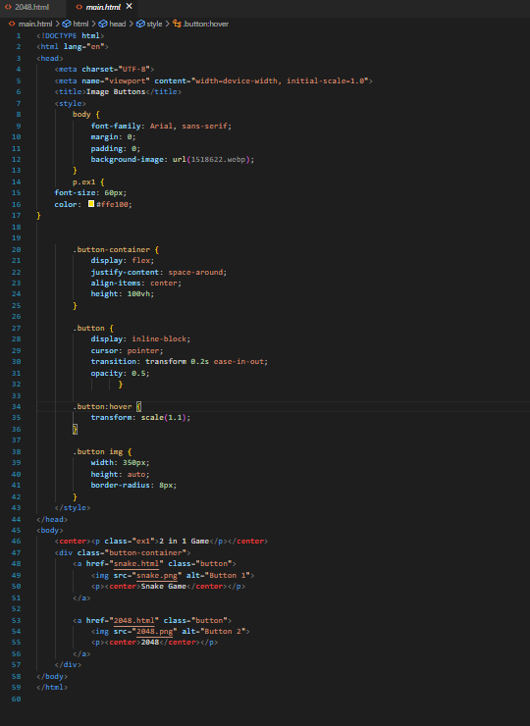**Main page-**

**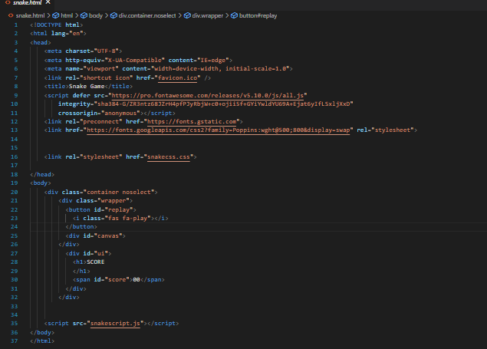***Snake Game-*

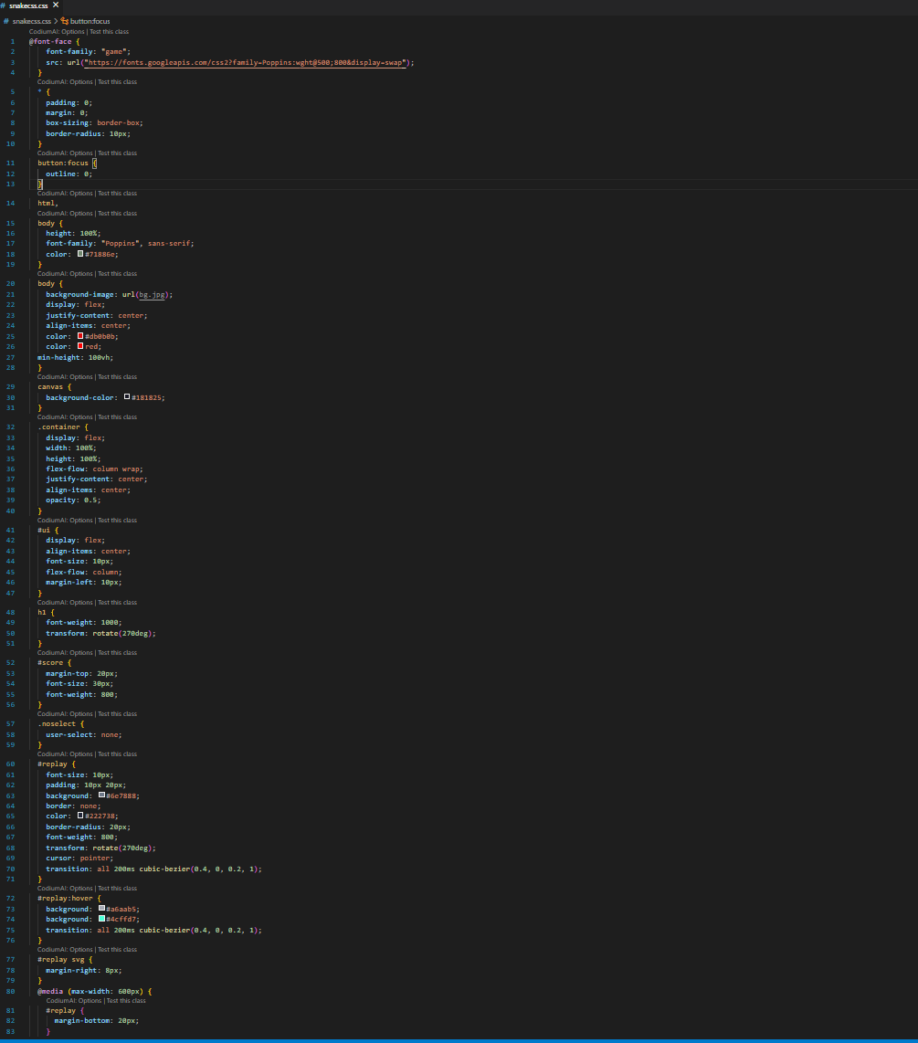

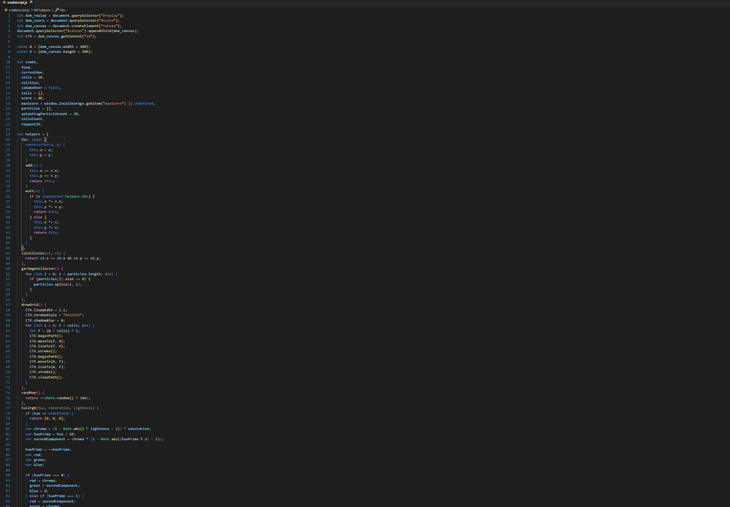

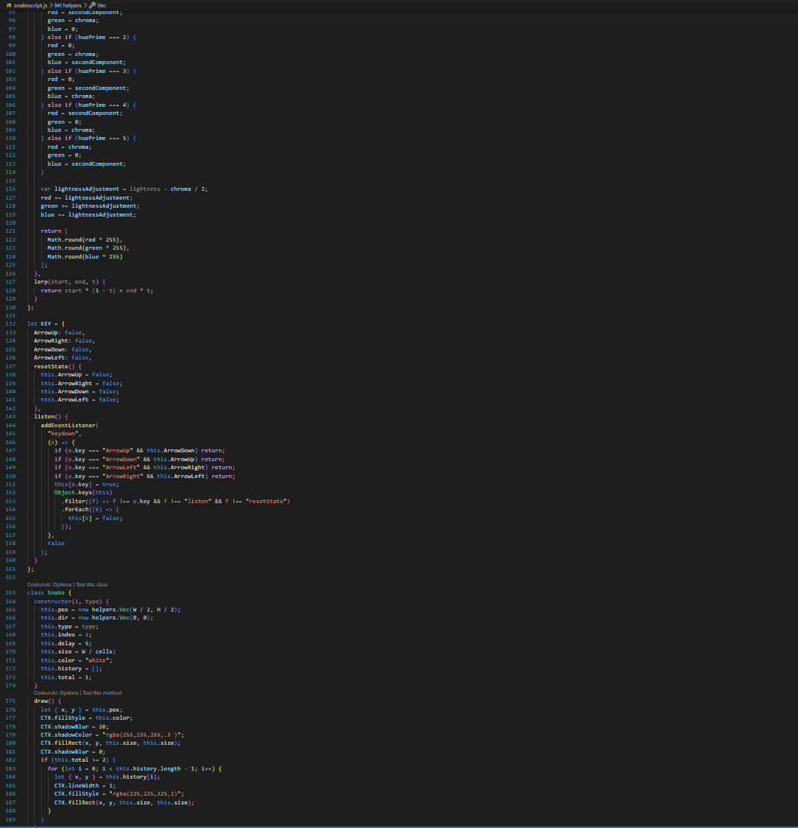

2048-

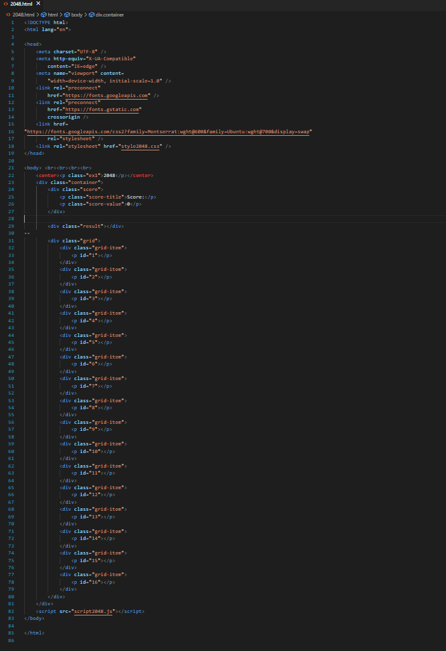

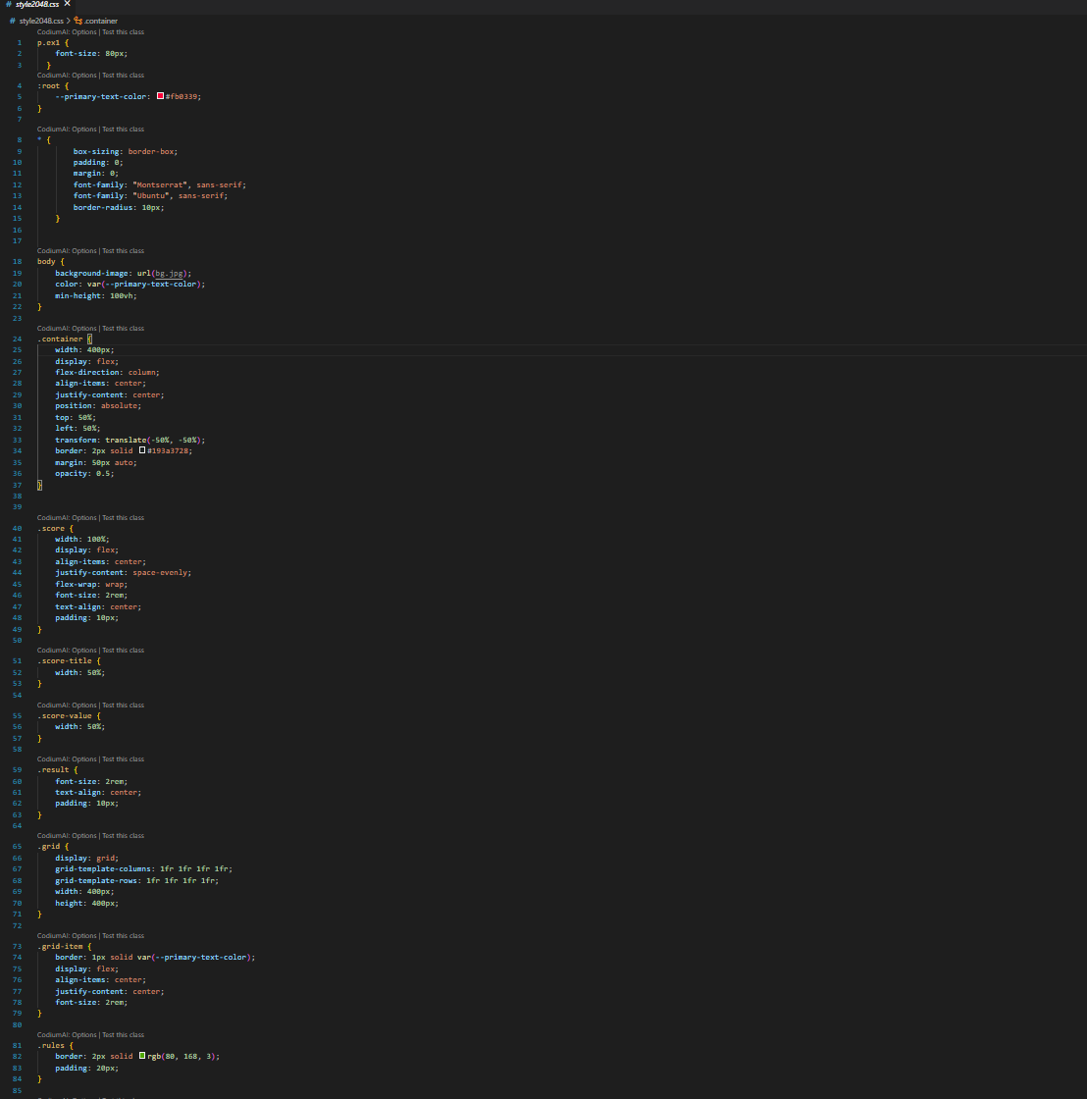

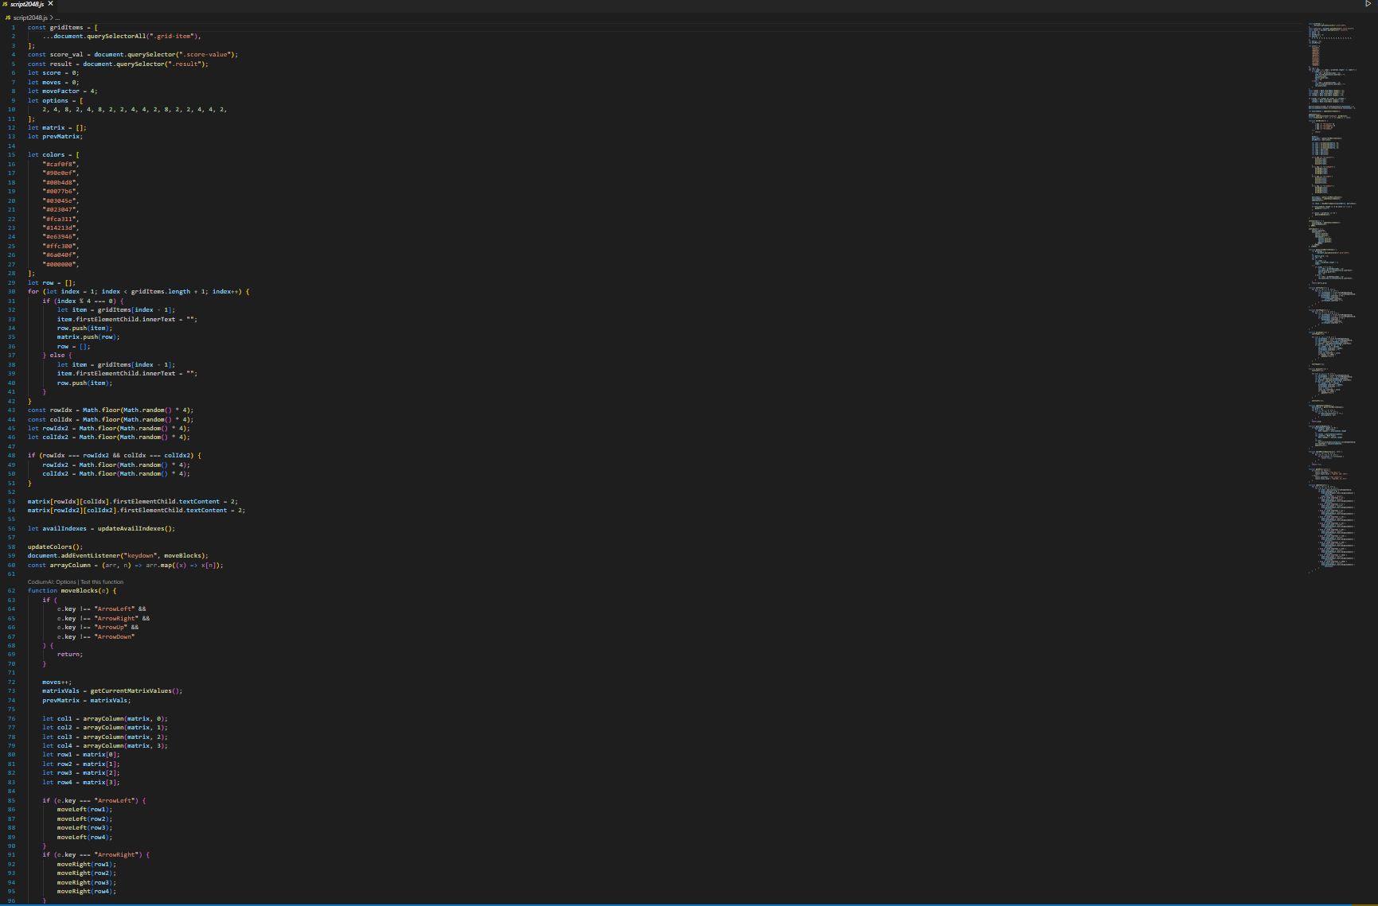

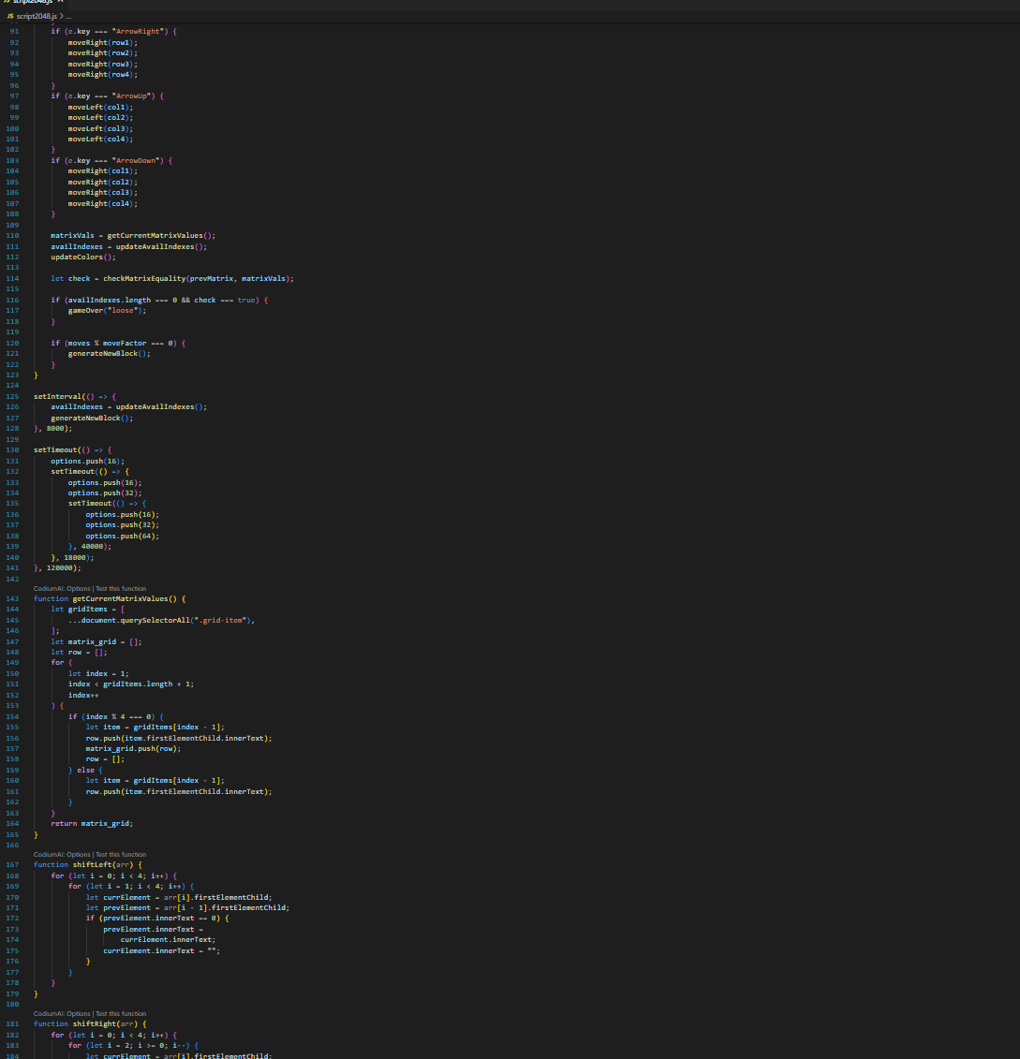

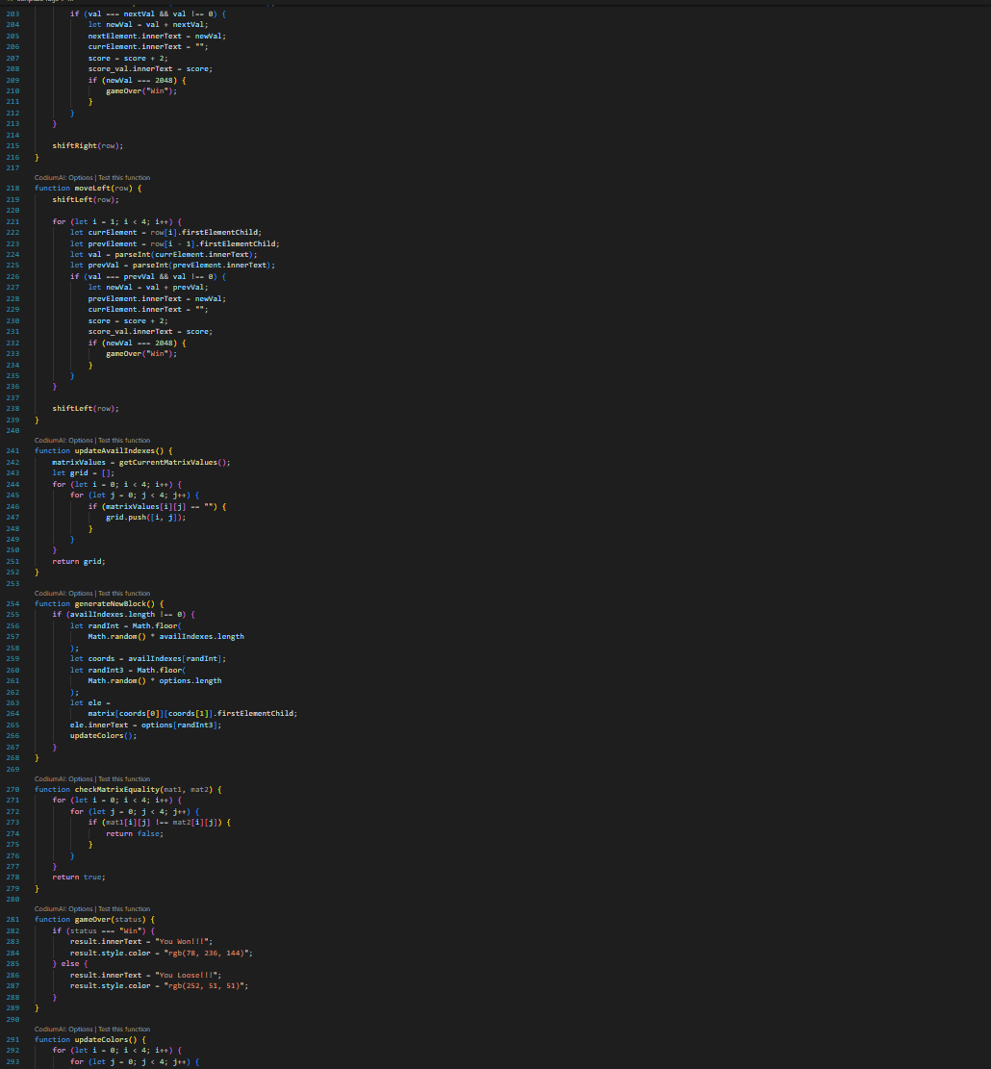

Snapshots(Output)-

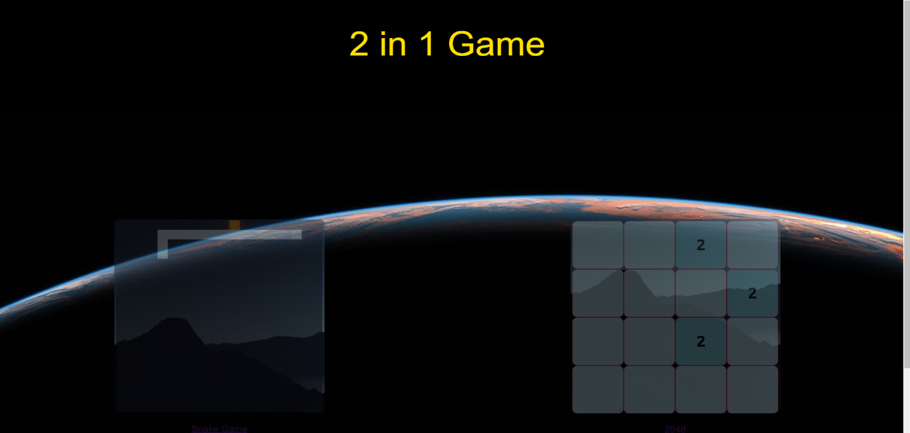

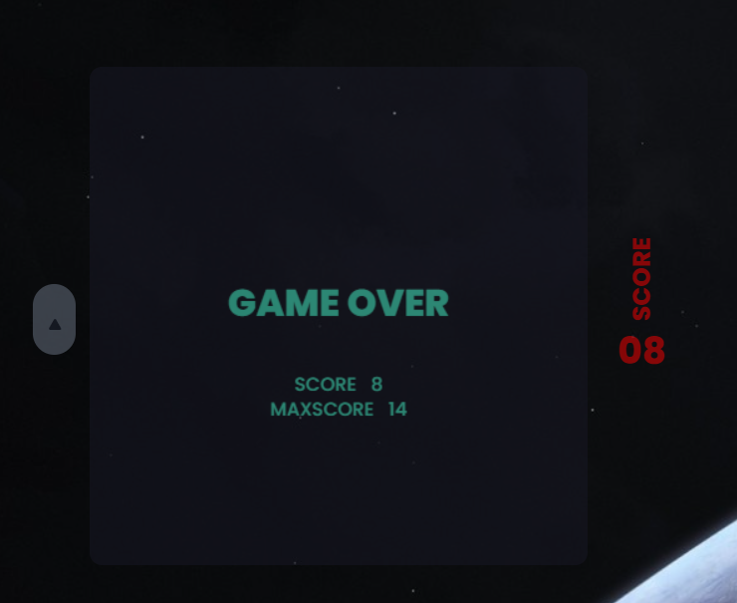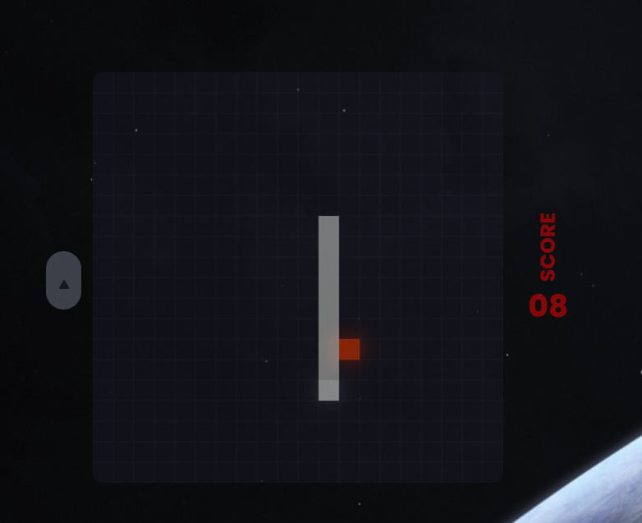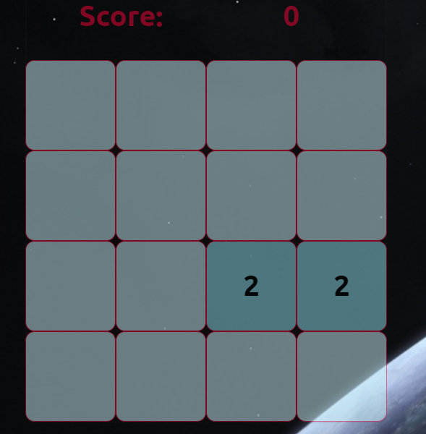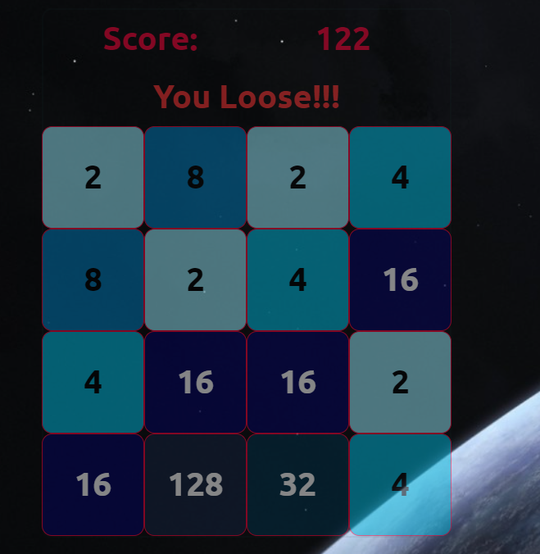

2048(Snippet)-

Snake(Snippet)-

Conclusion-

This project underscores the versatility of modern web technologies, with JavaScript, HTML, and CSS forming the foundation for robust game logic, interactive elements, and stylish presentation. The commitment to cross-browser compatibility ensures accessibility across a variety of platforms, making the game widely available to a diverse audience.

As we reflect on the journey of creating the "2-in-1 Game (Snake + 2048)" we celebrate not only the technical achievements but also the fusion of innovation and nostalgia. The project serves as a testament to the enduring appeal of classic games and the limitless possibilities offered by creative game development.

In the spirit of continuous improvement, user feedback will be a valuable asset for future refinements and updates. The development team remains committed to maintaining the project's quality, exploring additional features, and ensuring a delightful gaming experience for users of all ages.

In conclusion, the "2-in-1 Game (Snake + 2048)" invites players to embark on a journey that bridges the gap between the familiar and the novel. It stands as a testament to the timelessness of classic games and the boundless creativity that propels the world of web-based gaming into the future.

Top of Form

Executive Summary

The "2-in-1 Game (Snake + 2048)" is an innovative and engaging webbased gaming application that combines the classic Snake and 2048 games into a single, seamless experience. Developed using cutting-edge technologies such as JavaScript, HTML, and CSS, this project offers users a unique and entertaining way to relive the excitement of these iconic games.

Key Features:

* 1. Diverse Gameplay:

• Users can enjoy the strategic challenges of merging tiles in the 2048 game.

• The dynamic and fast-paced action of controlling a snake in the classic Snake game provides a contrasting yet complementary gaming experience.

* 1. Intuitive Integration:

• The project seamlessly integrates both games within a single interface, allowing users to switch effortlessly between Snake and 2048.

• An intuitive menu system enhances user experience, ensuring easy navigation between the two games.

* 1. Technological Foundation:

• Leveraging JavaScript for core game logic ensures a responsive and interactive user interface.

• HTML and CSS contribute to the structure, layout, and visual appeal of the web-based gaming application.

* 1. User-Friendly Design:

• The project prioritizes user experience with responsive design, making the game accessible across various devices and browsers.

• Visually appealing graphics and a straightforward interface cater to users of all ages and gaming backgrounds.

The "2-in-1 Game (Snake + 2048)" project is an exciting venture that brings together nostalgia and innovation in the world of web-based gaming. With its unique combination of strategic thinking and arcade-style action, this gaming application is poised to captivate a diverse audience. The use of modern web technologies ensures a smooth and enjoyable gaming experience, making it a standout addition to the gaming landscape. This project not only showcases the versatility of JavaScript but also highlights the potential for creative game development that resonates with users worldwide.

Reference-

1. *Google-*

*https://www.google.com/*

1. *Chatgpt-https://chat.openai.com/?next=%2Fc%2Fc32813a0-f508-495b-9e15-d12f2cbf4119*
2. *Greek for greeks-* *https://www.geeksforgeeks.org/*